OXI converting downloaded data instructions:

Table of Contents

Expected Workflow: 1

Notebook Decision Flowchart: 2

When to use single session workflow notebook (xnat2BIDS4session.ipynb): 2

When to use single session workflow notebook (multiSubjectsAndSessions2BIDS.ipynb): 3

How to use the “Download Images” Tab and options: 4

Option 1: Download via Desktop Client 4

Option 2: ZIP download 7

# Expected Workflow:

These instructions were written to help users run one of two notebooks that can convert data downloaded from OXI back into BIDS structure for local use. There are only two libraries (os, and shutil) used within the notebooks if you have done previous instruction lets it is likely you have the libraries. If you do not please get these installed before running the notebooks.

# Notebook Decision Flowchart:

## When to use single session workflow notebook (xnat2BIDS4session.ipynb):

If you download using the bulk actions menu by selecting which scans to download:

Verify you did this by looking at your unzipped folder structure. If it contains a ‘files’ folder within the scan you should use the xnat2BIDS4session.ipynb notebook:

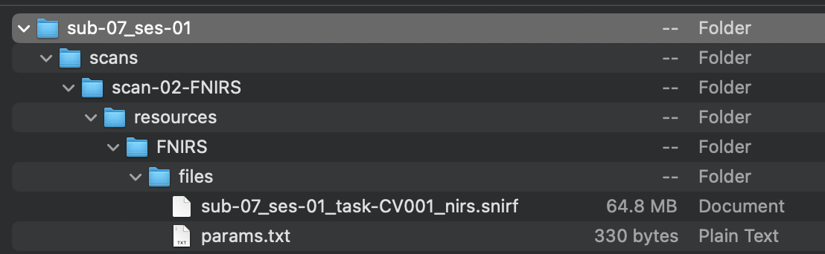

## When to use single session workflow notebook (multiSubjectsAndSessions2BIDS.ipynb):

If you download using any of the following options:

1. The download button within file manager

1. The download images either at a subject or project level

Please read NOTE on next page about this option

**Note: Please ensure the following options are checked (highlighted in the image)**

# How to use the “Download Images” Tab and options:

There are two options you will be able to download using:

## Option 1: Download via Desktop Client

* 1. This will use the desktop client you to download the data (please have it downloaded using the **link in the menu**)

* 1. Select the session you would like to download and the scan formats as well as scan types you would like to download then click submit. The following window will open and click Download via app:

* 1. Another window will open (unless you have allowed for always allow) to confirm opening the desktop client, confirm “Open XNAT-Desktop-Client”

* 1. Within the desktop client you will be asked to choose where to download the scans to, click the browse button and confirm a destination. In this example the downloads folder was chosen then hit download

* 1. Clicking download will launch a new screen with the status on your download:

* 1. Once complete the downloaded scans should be at the destination you choose:

* 1. You are ready to convert to BIDS structure using the multiSubjectsAndSessions2BIDS.ipynb notebook. Please navigate to the next section for details

## Option 2: ZIP download

1. This will use the browser to download the data in zipped format
2. Select the session you would like to download and the scan formats as well as scan types you would like to download then click submit. The following window will open and click Download ZIP:

1. A zipped folder should start downloading once complete unzip the folder



1. You are ready to convert to BIDS structure using the multiSubjectsAndSessions2BIDS.ipynb notebook. Please navigate to the next section for details

# Running the conversion notebooks:

Instructions for individual notebooks are written within the notebook itself. Please follow those steps to run the notebooks. There are one area within either notebook that you will have to edit.

xnat2BIDS4session.ipynb:

multiSubjectsAndSessions2BIDS.ipynb:

## General instructions and tips:

1. Edit the paths needed to run either notebook **BE CAREFUL TO NOT INCLUDE A ‘/’ AT THE END OF ANY PATH**
2. Once you edit the paths run the cell
3. The converted BIDS structure data should be available at the destination that you provided pathToBIDSReconstruction/Session**s**_BIDS OR (pathToBIDSReconstruction)/ Session_BIDS depending on which notebook was run
4. Here are some examples of converted data:

xnat2BIDS4session.ipynb

multiSubjectsAndSessions2BIDS.ipynb

